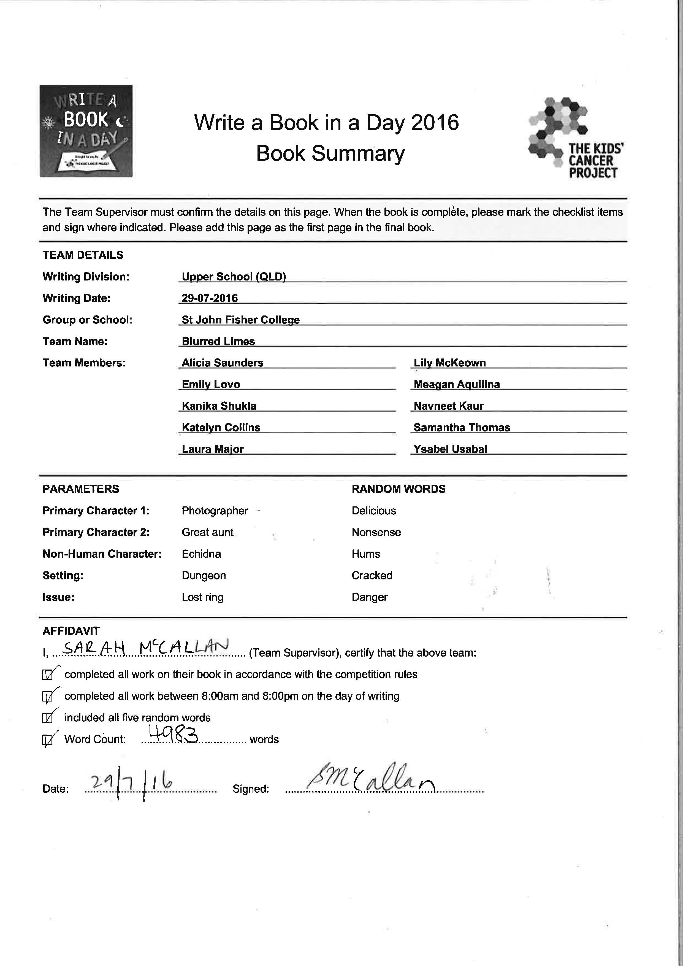

Copyright Notice
This is a work of fiction. Names, character, places and incidents are either a product of the authors’ imagination or, if real, used factiously. All content contained herein are included for entertainment purposes only and should not be relied on for accuracy of replicated.

First published in Australia 2016 by the above mentioned authors at St John Fisher College Bracken Ridge.

Text © 2016 and Illustrations © 2016
Blurred Limes

WARNING

This original material has been produced and communicated to you on behalf of St John Fisher College pursuant to Part VB of the Copyright Act 1968 (the Act). The text and images within this book may be subject to copyright under the Act. Further reproduction or communication of this material by you may be the subject of copyright protection under the Act. Do not remove this notice.

Printed and bound in Australia by St John Fisher College

All rights reserved. No part of this book may be reproduced, transmitted, or stored in an information retrieval system by any form or by any means, without prior written permission from the publisher.

Parameters given by KSPFBC
Characters: Photographer, Great Aunt, Echidna
Setting: Dungeon
Issue: Lost ring
Random Words: Delicious, nonsense, hums, cracked, danger

Contents
Copyright Notice 2
Acknowledgements 4
Message for the Children 4
5
Chapter 1 6
Chapter 2 8
Chapter 3 9
Chapter 4 12
Chapter 5 14
Chapter 6 17
Chapter 7 18
Chapter 8 20
Chapter 9 22
Epilogue 24

Acknowledgements
We would like to thank Write-A-Book-In-A-Day for giving us the opportunity to be able to help the children of the Kids Cancer Project. We would also like to thank our teachers, Miss Sarah McCallen, Miss Shari Dows, Mrs Jo Winlaw, Mr Simon Rowe, Mrs Karen Formosa for allowing us and helping while we participate in this competition. To all those who donated money or gave up their time to make this day possible, we thank you for supporting such a good cause. We would like to thank Bracken Ridge McDonalds for providing lunch as well as Dominos for providing dinner for us.
Thank you all so much for your continued support throughout this project.
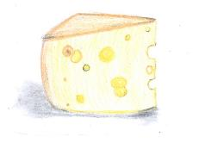

Message for the Children
To our beautiful readers, this book is dedicated to you. We hope you enjoy living this mystery as much as we enjoyed writing and illustrating it for you. May this inspire you to be brave, optimistic and honest.
Dare to be strong even at the toughest of times.
Love the Blurred Limes
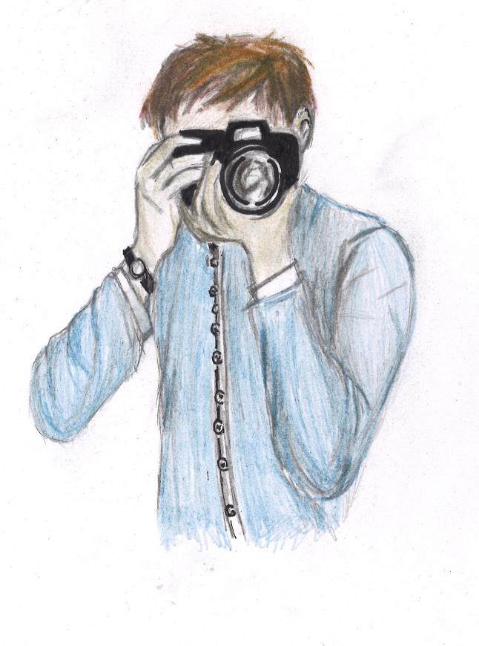

Chapter 1
Weddings are usually the most exciting day of the bride and groom’s life, but for Amy and Carl their day was not filled with the kind of excitement you would expect.
The bride and groom had been counting down the days and the big event had finally arrived. The beautiful Melbourne church was decorated with roses, an array of pinks, oranges and yellows like the sky at sunset. The guests slowly started pouring in and taking their seats. Every seat in the church was filled with family and friends who were all desperately waiting for the bride to arrive.
All except one. Amy’s great aunt, Gertrude, was hunched over in the back corner, rolling her eyes in disgust. Amy was surprised that Gertrude even showed up after the huge brawl they had last year over her choice of groom. Gertrude had thought their relationship was complete and utter nonsense ever since he overcooked her meal on their first encounter. Gertrude’s false teeth were definitely not strong enough to chew through that dry and leathery steak of his. But, nevertheless, today was the day they tied the knot. Gertrude was more than a little sour.
Over near the cheese platter, Ben, Carl’s cousin, was nervously feasting on every kind of cheese he could. He didn’t adore the idea of weddings; being a photographer, he had photographed so many in the past and each one was a cruel reminder of his own non-existent love life. Walking away, he clutched his camera with sweating palms while he captured pictures of the guests.
The wedding began with the priest appearing at the altar. He looked at the band as a cue for them to start. As the unforgettable wedding march played, the hums of the guests filled the church. Amy gracefully sauntered down the aisle as the guests rose from their seats. Following the bride was Eddie, the couple’s good echidna friend, acting as the ring bearer. As Amy reached her awaiting groom, a tear of pure happiness began to roll down her cheeks. When Eddie arrived at the altar to present the rings, a deafening scream from the bride pierced through the ears of every guest.

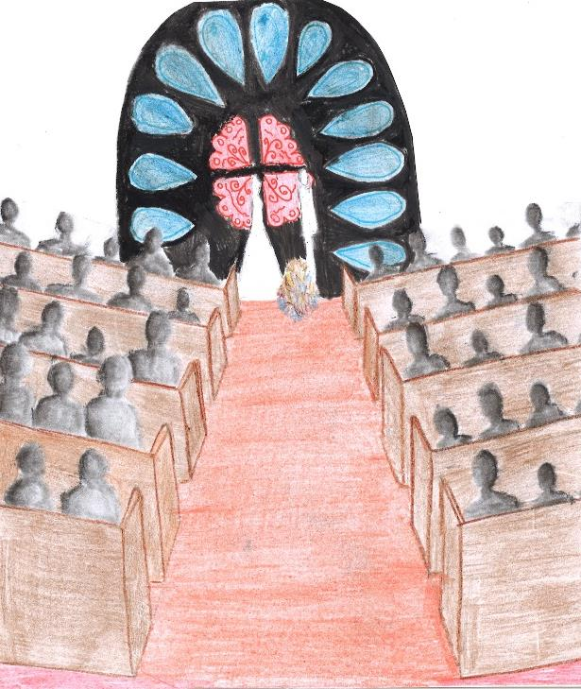

Chapter 2
Time seemed to slow down. The groom looked down at the open box before him. In there, lay a bright orange ring, a delicious cheezel to be exact. Whispers and gasps could be heard all around and many were leaning over the pews just to get a look at what all the fuss was about.
“Who could have done this?
“What’s in there?”
“A cheezel?!”
Finally, the bride’s squeal broke the crowd’s chaos, and everyone turned to the front of the church in silence. Out of embarrassment, Amy ran back down the aisle, practically foaming at the mouth.
Right before she made her dramatic exit through the church doors, she turned around and drew in a large breath, “Great Aunt Gertrude did this!” she screamed.
Family and friends of the couple all quickly turned their heads once again, though this time to look where Amy’s outstretched finger was pointing.
“Me?” Gertrude pointed at herself in astonishment, “Why would I do this?”
All of a sudden, Ben’s shaky voice piped up from behind, “Well…uh, you do hate Carl.”
He began to shuffle on his feet and looked around uncomfortably. He didn’t dare look grumpy old Gertrude in the eye, especially after accusing her of possibly sabotaging the wedding.
Gertrude’s eyes squinted even more than usual as she gave Ben a glare, “Who even invited you? I have never seen you before in my life,” she grumbled as she curled her lips in disgust.
His eyes widened and mouth fell open. “I’m a cousin of the groom thank you very much, and the photographer!” he said, offended, this time looking right into Gertrude’s beady eyes. “You probably couldn’t see me over those obnoxious glasses of yours!”
“Well let me tell you something, Ben-“
“Stop! Just Stop!” Amy yelled flailing her arms around in frustration. “This was supposed to be my day and instead of a ring, I got a cheezel! A cheezel for crying out loud!”
With a frustrated sigh she left, but this wasn’t enough to keep Gertrude from swallowing her comments. “Hmph. Well, he wasn’t good enough for her anyway.”
“You know what? You should be the one looking for the ring,” The groom’s mother was the first to speak since the whole ordeal, and everyone else followed suit, mutters of agreement filling the room.
“I think I saw it fall down the drain. You should start looking there.” Ben said condescendingly.
“Maybe you should help too. You know, just to make sure I don’t escape or cause even more of a fuss,” suggested Gertrude, glaring pointedly towards the guests.
Ben gave it some thought, then agreed much to Gertrude’s dismay.
“Oh, don’t forget me!” Eddie piped up. “I’m the ring bearer. I should accompany you too, Mr Ben!”
And it was decided.
Ben sighed. Here we go . . .

Chapter 3
The patchwork trio made their way through the staring congregation, their scathing glances like fiery darts. They pushed towards the large doors at the back of the church that lead underground, to where the ring supposedly was. The words DUNGEON were slashed across the metal doors in scarlet red paint and a padlock covered in grime interlocked the two handles.
“Oh no! We can’t possibly go now. I guess the ring is lost forever.” Ben exclaimed, faking despair.
“If they’re going to accuse me of stealing that blasted ring, I’m going to find it!” Gertrude squawked, yanking open her colossal handbag and retrieving a pair of bolt cutters from within.
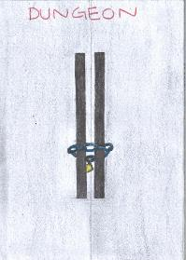
“Holy macaroni and cheese!” Ben proclaimed “Why do have bolt cutters in your handbag?!”
“No time for questions, young man!” Gertrude declared, wrenching the iron doors open with unusual strength for an old lady. She threw the bolt cutters to the side and disappeared down the stairs behind the door. Ben reluctantly followed.
Eddie looked over his shoulder wistfully, uttered an almost inaudible sigh and trailed the two squabbling humans beneath the surface.
As the three descended the staircase, a loud slam rang throughout their ears, followed by muffled shrieks.
“The door!” Ben yelled in fear. The noise that echoed only seconds previous was the sound of the large metal doors slamming shut, locking them inside.
“Only one thing to do, troops!” Gertrude announced, “We have to go forward!”
“It has only been a minute and we have already managed to get ourselves locked in a dungeon, while searching for a tiny object, in the complete dark!”
“Well it was your idea to come down here, Mr Ben.” Eddie peeped, staring at the photographer, warily, instantly regretting what he had said. Ben only huffed and continued his descent.
When they made it to the bottom of the steps they found themselves engulfed by darkness. It seemed like a never-ending abyss, stretching before them, a blackness that could swallow them whole. The only sounds to be heard was the slight scuffling in the distance and the steady breaths of the trio. The air was thick with anticipation and fear. Danger seemed to multiply with every second that passed. Just as Ben and Eddie began to think all hope was lost, quick as a flash, Gertrude snatched the camera hanging from the photographer’s neck.
“We can use the flash to see!” Gertrude shrilled. The old lady quickly snapped a picture, illuminating the cavern with bright light. The flash lit up the dungeon for only a few seconds, but it was long enough to see where they needed to go.
“Straight ahead!” Gertrude called, running off in the direction she described.
CLICK. “We need to go right!”
CLICK. “Passageway to the left!”
CLICK. A small flicker.
CLICK. Another small flicker.
“Blasted technology, I have longer to live than this pesky gadget and I’m no spring chicken.” Gertrude complained, sighing in disbelief.
“What are w-w-we going to do now?” whimpered Eddie, looking up at the two humans in despair.
“Let’s face it, we are never going to find the ring down here.” Ben whinged.
“Never fear!” Gertrude commanded. Despite the worst of circumstances, Gertrude didn’t give up. Not because of any sort of positive thinking, she was just that stubborn. She ran across to the closest wall of the dungeon, and broke a piece of wood off. She placed her handbag on the ground and began to rummage around for something, she began to throw things out when she couldn’t find it.
Out came a pair of knitting needles, a ball of yarn, a fire extinguisher, a watering can. Ben even glanced what he thought was the complete works of William Shakespeare.
“No. No. No. No. No. No . . . Aha!” Gertrude exclaimed when she finally pulled out a box of matches. She struck one and lit the piece of wood on fire. The dungeon was once again illuminated, the underground passages shone with flickering gold light. The crackle of the fire was a reassuring sound, and provided warmth for the trio.
“Let’s go!” shouted Gertrude, once again starting off without the others.
“Come along, Mr Ben.” Eddie chimed, following the footsteps of the crazy old lady.

Chapter 4
Shuffling through the damp, dark dungeon was a struggle for the team to say the least.
“Could you quit stepping on my heels?” Gertrude snapped, waving the torch alarmingly close to Ben’s face. “I swear, back in my day, young men like you were much more polite.”
Ben barely missed the flame, ducking to save his eyebrows from an early and unfortunate demise.
“I wouldn’t be if you weren’t moving at five kilometres an hour,” he muttered in response.
Their exchange faded into a tense silence as they made their way through the winding passageways. Ben was silently thankful for Gertrude’s crazy antics and tendency to carry miscellaneous albeit helpful objects on her person at all times. The light from the torch was appreciated, and filled the dungeon with a hazy golden glow. But the place was far from comforting. With every shift or turn or Gertrude’s arm, sinister shadows were cast against the walls like outstretched hands.
“Hey, look!” Gertrude called suddenly, making a dash forward and almost stumbling out of her high heels.
As she hurried ahead with their only source of light, Ben and Eddie had no choice but to follow. Suddenly, Eddie’s spine grazed the side of a protruding pipe, emitting a trickle of water, tainted a dark green. He gasped as he scurried by, his eyes frantically searching for Ben, clutching his shirt as they ran.
When they finally caught up to Gertrude, she was eagerly riffling through her bag. The sight drew nervous butterflies from Ben’s stomach. What was she going to do this time?
But surprisingly, Gertrude came up empty-handed.
“Darn it!” she huffed, frustrated. “I was sure I had something in here.”
“Something for what?” Eddie asked quietly.
Gertrude leant against the wall, which, at second glance, was not a wall at all, but a door. It was enormous and looked heavy enough to squish them into pancakes if it happened to collapse on top of them. The wooden panels were old – there was no doubt about it – but they didn’t appear to have weakened even slightly. It was almost intimidating.
“I reckon we might’ve hit the jackpot, boys,” Gertrude’s smile split across her face. “Only problem is, it’s locked up pretty tight. Any idea how we can get in?”
Ben shuffled nervously on his feet. “I don’t think this is a good—"
“My spines!” Eddie blurted out. His eyes widened and he covered his beak, suddenly bashful. “I-I mean . . . maybe we could . . .”

Gertrude let out a bellowing laugh that echoed through the dungeon. “Oh, you’re a genius, Eddie!” Not wasting another second, she plucked a spine from his back – much to Eddie’s squeak of protest – and quickly wedged it into the padlock.
A clicking sound rang through the air, and they were in.
“Cheesus!” Ben exclaimed.
The sight before them was not what they had expected. Ratty bookshelves towered above them, packed with books. Ben wondered if he’d get a splinter from just looking at it. Gertrude charged ahead, fumbling with the books, ripping their pages and scattering their layers of dust into the air.
With a triumphant gasp, Gertrude yanked a particularly large book from the highest shelf, having stood on a pile of other literature which had already fallen prey to her rampant curiosity. With a shake, a map fell at her feet.
“It’s a layout of the dungeon!” she gasped. Ben and Eddie gathered around her.
“It can help us get out,” Eddie said.
Ben felt his stomach somersault. This could be it, he thought. My ticket out!
Suddenly, he grabbed for the map. “There’s a sewerage tunnel through here!” Ben almost yelled. “Maybe the ring’s that way. You said it fell down the drain, right? Come on, we’ve gotta check it out!”
As Ben bolted towards the door again, Gertrude and Eddie exchanged puzzled looks.
“Since when did he become captain of the cheer squad?” Gertrude whispered, nudging the echidna at her side. “He wasn’t that enthusiastic five minutes ago.”
Eddie shrugged, a relieved smile on his face. “Mr Ben is funny like that,” he said.
Gertrude decided to let it go, trailing after Ben. They had a ring to find, after all.

Chapter 5
Ben eagerly clutched the delicate map, it’s inscribing illuminated by the fiery glow from the torch held tightly in Gertrude’s hand. He peered closely at the faded ink, trying to make sense of the intricate maze of passages and tunnels.
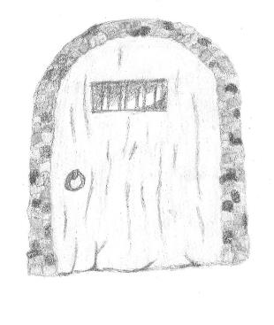
“This way!” Ben impatiently urged, gesturing towards the narrowing tunnel to his left.
His attention returned to the map, this time, focussing on the drain in the bottom left hand corner. Ben was intent on getting to the drain as soon as possible, so he could prove that the ring was lost and get out of the dungeon once and for all.
“Um.. er.. are you sure it’s that way Mr Ben?” Eddie softly piped, hoping not to offend Ben.
“Of course he’s not! He’s a photographer, not a map reader-er!” Gertrude grumbled, defiantly rolling her eyes and trudging reluctantly behind.
Ben shot Gertrude a piercing stare, before returning his focus back to the path ahead.
Eddie inhaled in the heavy air, letting out a small cough as he noticed an oddly faint smell of rotting fruit. He felt the ground beneath his claws becoming increasingly damp and viscous, and cautiously glanced down to inspect the floor. Is that… bat droppings? Eddie wondered, curiosity looming over his face.
Beginning to become concerned, he sharply turned around in an attempt to identify any danger. But to his disappointment, the path behind them had dulled to a hazy black. The light from the torch was dwindling and was no longer able to penetrate the thick darkness. Before Eddie could alert the others, they were stunned by a chorus of high-pitched screeching and scratching noises. The commotion echoed through the tunnel, hitting their eardrums like nails to a chalkboard.
“Are those bats?” Ben shrieked in a panic, clasping his hands over his ears as he began to quicken his pace.
“No. They’re butterflies, Ben.” Gertrude rolled her eyes, trying hard to suppress the look of worry on her face and think rationally.
With Eddie now stumbling about in circles, Gertrude was cautious not to worsen the panic. She swiftly scooped him up, tucked him under her arm and ran as fast as a Great Aunt could, which for Gertrude, was faster than Ben. She scanned left and right, desperate to locate another room or passage they could divert into. Gertrude spotted a narrow opening to the right, and without hesitation, swerved straight through it. She pulled out a colourful fruit platter from her (very spacious-on-the-inside) purse, placed it on the ground to satisfy the bats, and sped off with Eddie still clutched under her arm.
Unknown to her, Gertrude’s better-than-average speed had left Ben miles behind. Unable to locate an exit to the passage, Ben had no choice but to lay flat on the bat-dropping-covered-floor to avoid the path of the incoming bats. His black suit camouflaged well with the sludge to act as a disguise. Ben waited for the bats to pass over his head, and until their cries became reassuringly faint before picking himself up and wiping the droppings off his face.
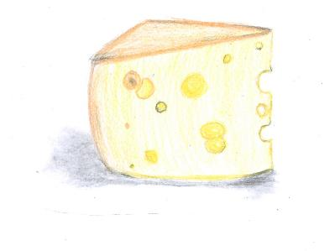
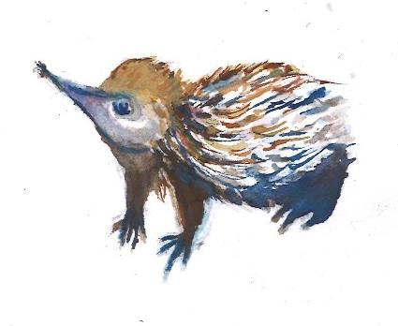

Chapter 6
Ben’s heart pounded in his ears like a drum, frantic breaths ripping from his chest. He almost stumbled – his muscles felt as though they’d been replaced with aeroplane jelly. Frantically he whipped his head around, searching for any sign of his friends.
Where are they? I could have sworn they were here just a moment ago . . .
Ben ran and ran until his feet landed in something wet and soupy. A foul smell entered his nostrils. He couldn’t see a thing in the darkness – Gertrude had taken the only source of light the group had – and his eyes struggled to adjust to the newfound blackness. But the scent was descriptive enough, and it practically overloaded his senses. He was standing in sewer water, and it was slowly creeping up his leg, first to his ankles, then to his calf. He shuddered to think what kind of horrors had made their home in that water. His desperate footsteps finally slowed to a stop.
“Where’s Gertrude? She’d have something weird to say right now,” Ben mumbled, suddenly feeling overwhelmingly cold. “And that stupid bag. She’d pull something out of it right now that could help us.”
He waded through the rising sludge, trying to ignore the way it felt as it seeped through his clothes and clung to his skin.
“And Eddie. He didn’t even need to get involved with this,” Ben could feel a cocktail of frustration, anger and hopelessness erupt inside of him. It was a hard drink to swallow. “He was just trying to do the right thing, and look what I’ve done . . .”
It was likely he’d never admit it, but Ben knew he missed them.
For the first time in their crazy adventure, he felt alone.
The world didn’t give him much time to lament, as he became increasingly aware of the goopy sewerage that was gradually finding its way up his legs. He was almost knee-deep by now – he could feel it. And as it stood, the scent was enough to make his eyes water with disgust. He was certain that he did not want it any closer to his nose than it already was.
Ben decided to keep moving before his resolve had completely faded from within him. It was hard to see the bright side of things in pitch blackness, but he had to try.
Suddenly, the crash of a tidal wave echoed through the dungeon. Water rushed and slammed against the walls. The flooding had gotten worse. Ben gasped, squeezing his eyes shut.
“Gertrude! Eddie!” he yelled in a desperate last effort, cringing as his voice cracked with fear. “Now would be a good time!”
As if on cue, an enormous, rubber object soared above his head, landing in the water behind him. Ben shrieked as the water splashed all over him. He heard a familiar, boisterous laugh and relief washed over him.
“Hey, Ben!” called Gertrude, her torch extended towards him, filling his eyes with warm, welcoming light. “You getting in or what?”

Chapter 7
Gertrude felt a cold sensation creeping up her old, crippled body and slowly started to reach to the height of her bony shins. She peered down to inspect the bizarre wetness. There, little Eddie was covered in dirty green sewage water, struggling to keep afloat. The whole dungeon was flooded and the water level was rising by the minute. Gertrude was deep in thought, wondering how this may have happened and how the heck she would get all of them out. When she heard a quiet murmur from Eddie as his head went under. Gertrude scooped him up and placed him inside the safety of her giant handbag.
“I’m so sorry, this is all my fault,” he whimpered. “It was my spine! I accidentally cut a pipe when we were running.”
“Shut up, Eddie! This is not the time for your pity-party!” Gertrude snapped.
“Okay, Ben, we are going to have to come up with an idea before we all turn to drowned rats and swallow this dirty poo water,” She shrieked, turning to Ben.
Her jaw dropped as she turned to see only darkness and began to panic as Ben was no longer behind her. She hadn’t known Ben for long, but long enough to know he was not quick on his feet. Gertrude knew he was the outcast in his family and could definitely relate as she felt the same way in her family. Gertrude was the crazy, out-there great aunty who was the outsider of the otherwise traditional and conservative family. In this short time of getting to know Ben, she had formed a space in her heart for him and knew she would have to come to his rescue.
She began to rummage through her hand bag trying to search for something useful, whilst trying not to scratch herself on Eddie’s spikes. She finally found it, a palm sized box.
Eddie looked puzzled. “How’s that going to help us?”
Gertrude pulled the toggle and the small box folded out to form a full sized raft. Both of them raced for the already moving raft and Gertrude jumped in throwing her bag in first. The raft began to speed up and they could hear a faint call in the distance. With a joyous cry, Gertrude thrusted the boat forward and it became airborne for a few moments before coming back down with a mighty splash. She turned to see Ben, covered in sewer water and appearing quite miserable as he shook in his shoes.
What would you do without me? She thought to herself.

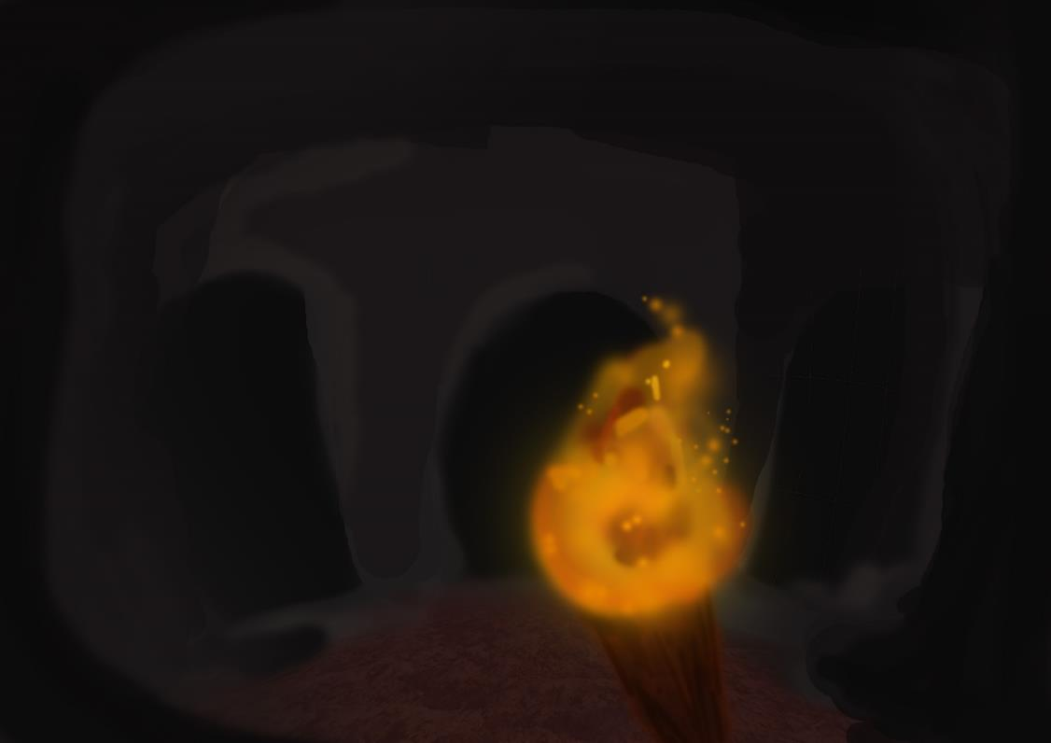

Chapter 8
Gertrude heaved Ben onto the raft, almost tumbling backwards into the foul water. Ben was overwhelmed with emotion – he’d just experienced what was possibly the most horrifying event in his entire life, handled it in a way that couldn’t possibly be more undignified, and now was flooded with so much relief that it made him weak in the knees.
“Why . . .” Ben muttered. “Why did you save me?”
Gertrude cocked an eyebrow at him, settling into a corner of the raft. “Would you prefer it if I didn’t?” she offered him a modest smile, worlds away from her usual, crazed grin.
Ben spluttered. “No, that’s not it at all!” he said. “It’s just . . .”
He couldn’t quite place the new look in Gertrude’s eyes, framed by ridiculously oversized glasses. It was softer, warmer, and resoundingly more normal. She was a tricky book to read, but she wasn’t waving her torch at him again, so Ben took it to mean she’d had a change of heart towards him. He appreciated it.
Gertrude seemed to read his thoughts. “Everyone’s worth saving,” she said with a wistful sigh. Ben knew she had a story for that. She always did. But she didn’t elaborate, so he assumed it was not his territory to explore.
“Some people just make it a bit harder than others,” she winked playfully, then turned back to watch the rocky walls of the dungeon pass by.
Minutes passed by in a comfortable silence. It was funny how near-death experiences changed things, Ben supposed. As they neared an arch, Gertrude stood and grabbed up at it, using its momentum to propel the boat forward. The sleeve of her cardigan was caught by the rock, and pulled it up slightly. The sight revealed make Ben double take.
“What on earth have you got on your arm?” he shrieked.
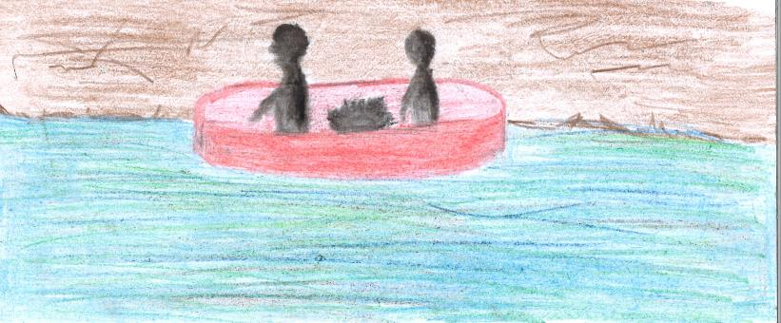
Gertrude shrugged and glanced at her exposed skin. Her arm was covered in an elaborate sleeve tattoo, an artwork of various colourful patterns, one of which was a skull and cross bones.
“Oh, that? It’s from my army days,” she chuckled, as though all sixty-something-year-olds were in the military. “Reminds me to always do the right thing.”
Ben felt a knot at the base of his throat. Guilt rushed over him.
“Uh . . . Gertrude? Eddie?” Ben looked over hesitantly, not daring to meet their expectant eyes. “There’s something I should tell you guys.”
“What’s that, then?” Gertrude said.
“I was the one who took the ring.”

Chapter 9
“Why would you do that? Do you know how scared I was? I had to endure being locked in a dungeon for you! I gave up one of my spikes! Do you know how hard those are to grow back?! And then we find out that it’s actually not down here, just in you back pocket the WHOLE time!” Eddie screamed in rage.
“Eddie, Eddie, calm down,” Gertrude soothed. “Let him explain his side of the story.”
“I was just so lonely,” Ben sobbed. “I wasn’t in any of the photos, I was their cousin as well, they were all having fun without me. I was jealous. Please forgive me, Eddie.”
“Ahh, I’m just ech-kidding ya,” joked Eddie, squealing with laughter.
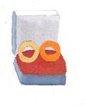
“We still have to find a way out of here,” voiced Gertrude, with a slightly worried look on her face, which was definitely unusual for the old lady. The water was angry, buffeting them side to side in their raft, as they raced through the maze of tunnels, carried higher and higer by the rushing torrent.
“How are we going to get out?!” Gertrude yelled in fear. The other two were shocked, they hadn’t ever see Gertrude afraid before.
“It’s going to be okay.” Ben comforted.
“How do you know?” yelled Gertrude.
“Well how did you know that we would be okay every time we were in trouble; we always overcame it. When we had no light, we survived. When we couldn’t unlock that door, we survived. When we were getting chased by those pesky bats, we survived. I think we’ll be able to survive a little bit of water.” Ben exclaimed above the noise of the water.
Just as Ben had said that, a familiar staircase came into view several metres in front of them.
“That’s it! That’s where we came in!” Eddie yelled with glee. Before Gertrude could even voice her concern about how they would be able to get out the locked door, the door burst open, the pressure of the water defeating the iron doors. The raft leapt out, soaring through the air, landing amidst the shocked guests. They floated up the aisle towards the altar, the crowds of finely dressed people staring in astonishment.
“The ring!” the bride screeched.
The previously silent, stunned crowd erupted into chaos. Eventually, after several long minutes of pandemonium and people clamouring towards the raft, the mob fell silent when a loud voice declared.
“STOP TALKING!” In the mayhem, people had forgotten about Eddie the echidna. Everyone thought Eddie was shy and quiet, and he was, but he was also an echidna. When he got angry, you knew he was angry.
After Eddie’s outburst, the room was so silent, you could have heard a pin drop.
“You found the ring?” the groom asked tentatively.
“Oh, yes, we did!” Eddie exclaimed, his mood shifting immediately. The guests all relaxed when they realised the echidna was no longer furious.
“How did you find it?” the bride questioned.
The old lady that had been silent since the bedlam erupted, now spoke up.
“Always, asking pesky questions, does it matter? Just get on with the blasted thing already.” Gertrude tutted as she emerged from the raft drenched with water.
The three heroes slid into the church pews and the guests looked around at each other, confused.
“Come on! I’m not going to live forever!” Gertrude yelled. And so the wedding began.

Epilogue
The sun beamed splashes of turquoise and scarlet as it radiated through the stained glass panes of the church. The fresh spring air married with the aroma of flowers; red roses and white gardenias. Birds chirped to a tune, almost in harmony to the soft piano for the modern version of “Bridal Chorus”.
As the door, frontal of the church, grandly opened, the room shimmered with a golden blaze. All eyes were set on the bride in a lace, backless dress. The silk material, soft like the petals on a flower, flowed down. Her blonde hair caught the sun’s beams as it reflected a slightly golden glisten. Her tan skin glowed, which was complimented by her perfect white smile. Her chocolate brown eyes fixated on the one man right in front of her. As their hands met, the whole audience felt their special bond, that no words could describe.
Snap, Snap. The bright flash of the camera capturing the moment. Ben couldn’t possibly take the photos at his own wedding so a good friend, Blanely Swiss, took his place.
“Do you, Ben Cheddar, take Heidi Brennan, to be your lawfully wedded wife, through sickness and in health, for as long as you both shall live?”
“I do!” Ben declared as his smile grew.
The priest continued, “And do you, Heidi Brennan, take Ben Cheddar, to be your lawfully wedded husband, through good times and bad, until death do you part?”
“I do!” Heidi answered as her smile grew with Bens.
“Could the ring bearer please come forward?” The priest asked.
Eddie shuffled forward with a white and gold box, carefully handing it over. Ben opened the box, his smile showed a sign of relief. He held up a cheezel and handed one over to Heidi.
“Say cheese!” Ben glanced over to see that Gertrude had managed to get hold of the camera and snap a photograph.
“You’ve got to brie kidding me..” Ben muttered.
THE END.
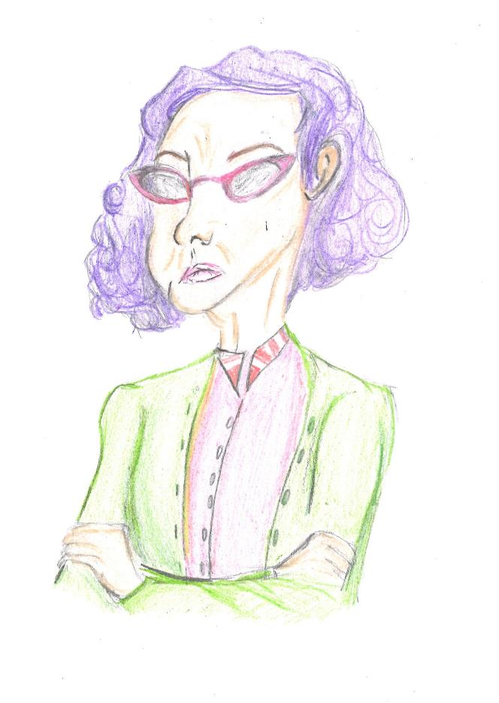
A shy little echidna, an eccentric old woman and a photographer with a secret - this trio of misfits are thrust into the heat of the action when a wedding ring goes missing. In its place, a cheezels. In order to save the day, the crazy cast of characters must venture deep into the dark depths of a dungeon, brave the horrors of sewer water, and find the ring just in time! A tale of excitement, friendship and cheezels, Say Cheese is an adventure you will not soon forget.

Recommended age: 10-16 ye

